

PRESS RELEASE

KKT chillers’ new Vario-Line

Efficient. Variable. Innovative.

Optimized cooling technology

*KKT chillers’ innovative Vario-Line comprises eight new chillers that automatically adapt their cooling capacity to the respective application at any given time, making them particularly precise and economic. The models’ variable cooling circuit covers a performance range between 6 and 28 kW.*

As basic standard equipment, the new chillers are fitted with RPM-regulated components such as a compressor and a ventilator as well as an electronic expansion valve. In this setup, KKT chillers applies the high-efficiency cooling agent R410A in connection with a compact micro-channel condenser. Thanks to the low filling quantities of cooling agent used, no extra maintenance cost arise and the Vario-Line chillers are not classified as dangerous goods when in transit. The intuitive, multi-lingual info display ensures maximum user-friendliness and fits perfectly with the compact design of the industrial casing.

The software, an in-house development, achieves a steady-state control accuracy of under +/- 0.5K without requiring any additional components. The digital data management comprises all relevant control variables such as temperatures, pressures and filling levels.

The Vario-Line guarantees safe operations without the application of special components at an environmental temperature range of between -20°C and 50°C. Due to the wide range of options in the water cycle, each vBoxX adapts individually to the respective customer application. The Vario-Line model range is suitable e.g. for the global machine tooling and laser industries as well as the healthcare sector. Requirements beyond these specifications can be met by means of special-purpose solutions that are customized for the specific application.

Performance tailored to the customers’ needs

‘As industrial processes frequently show load variations, the thermal load is usually not constant either. Consequently, today’s chillers are often bigger than actually necessary for a major share of load profiles. Up to now, this has often entailed relatively high emissions and excessive energy costs,’ Sascha Paulus, product manager at KKT chillers, describes the general situation before the launch of the Vario-Line.

‘The Vario-Line offers a solution to this problem, thanks to the application of the RPM-regulated compressor and ventilator. The steady-state electronic expansion valve automatically adapts the cooling capacity of the Vario-Line to the application’s current load profile. This means that the system generates only as much capacity as is needed at the moment,’ explains Paulus.

The Vario-Line is suitable for both indoor and outdoor installation. Its design goes perfectly with the Compact Line, which has previously won a Red Dot Award for its design concept. The basic models of the Vario-Line come in RAL7035 light grey, with the well designed metal plate spanning the control display in the middle of the device. The name of the new KKT chillers line alludes to the models’ variable equipment and wide range of applications.

Kasendorf, May 2015

|  |  |
| --- | --- |
| Published by:  ait-deutschland GmbH  Industriestraße 3 95359 Kasendorf  T +49 9228 9977 0 F +49 9228 9977 149 E info@kkt-chillers.com W www.kkt-chillers.com | For media inquiries please contact:  Nadine Stich Marketing and Communication Industriestraße 3 95359 Kasendorf  T +49 9228 9977 0 F +49 9228 9977 149 E nadine.stich@kkt-chillers.com |

About the brand:

Since 2012, KKT chillers has applied the company’s experiences and core competences at the Kasendorf site where it now develops, as part of ait-deutschland GmbH, joint projects on the energy-efficient use of resources with the brands alpha innotec and NOVELAN. In 2014, ait-deutschland GmbH’s team of 450 people generated a turnover of € 95 million, with KKT chillers accounting for € 16 million.

Press photos:



Image 1: Logo KKT chillers

Icon_AR.jpg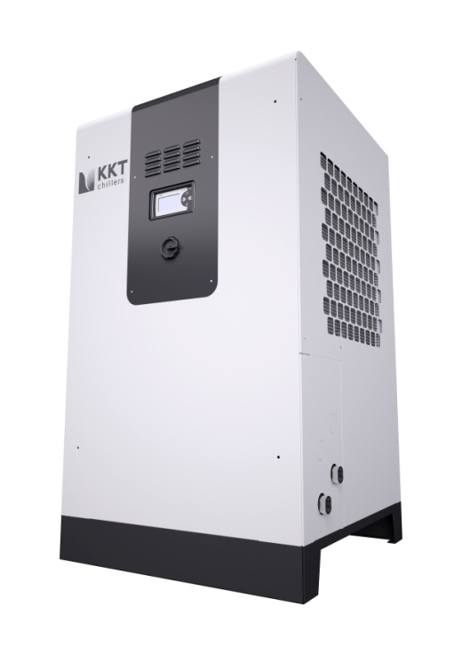

Image 2: vBoxX 12, Vario Line (housing size 1)



Image 3: QR Code Augmented Reality

Information text:

Scan the code and download the KKT chillers’ app for free.

Now just fix the camera of your mobile device on the

Vario-Line picture with the AR icon –

and you‘ll be surprised!

Please send a sample copy to: nadine.stich@kkt-chillers.com