
PRESS RELEASE

THERMODYNAMIXX – The success formula in heating and cooling.
KKT chillers provides thermal energy solutions in the performance range of 200 – 1,000 kW.

Refrigeration always entails the generation of heat and vice versa. This physical principle is the basis of the chiller technology. Summarized under the designations of MAGMA and ARCTIC, KKT chillers present thermal energy management systems that generate cold and heat at the same time by applying waste energy from the main process to a complementary process, thus creating a very energy-efficient solution. The main areas of application include larger commercial buildings and industrial procedures.
The MAGMA series stands for compact high-performance heat pumps that focus primarily on the generation of process water. The cooling capacity produced in the process can be utilized without requiring any additional energy input. ARCTIC units, on the other hand, generate up to 1,000 kW in refrigerating capacity to cool industrial processes. The waste heat entailed in this is subsequently utilized, without requiring any additional energy input, as industrial water and/or for drying and cleaning processes. The concept runs reliably within an ambient temperature range of –25°C to +50°C, with possible process temperatures ranging from –40°C to +70°C.
KKT chillers considers the crucial element in this performance area the focus on the demand-oriented specification of the individual type of device: Both series are based on identical components; the specific demand profile of the respective application alone decides about the actual arrangement of the individual components, which – depending on the required conditions of use – can be assembled, specified and aligned in terms of material, setup and sensors in an entirely customized approach.
For instance, depending on temperature range and storage capacity, a great variety of compressor technologies is applied. Another example is the kind of heat transmission, which is determined anew from project to project, depending on the heat carrier specifications. Even the pipework and the housing setup are optimized for the specific demand. This success formula in cooling and heating is complemented by a central building control system specifically aligned with the customer’s requirements.
A prime example for an energy-efficient THERMODYNAMIXX concept is South America’s second-largest brewery in Brazil, where two MAGMA units with a heating capacity of 500 kW each ensure both the heat generation for the pasteurizing and cleaning processes as well as the cooling of the brewing water. The new solution has replaced large energy consuming facilities such as the saturated steam generator and conventional water chillers. Another benefit on top of the lower installation efforts and space requirements is the great efficiency, which has led to a reduction in operating costs of over 50%. Consequently, the payback period has decreased to only a few months.

Kasendorf, August 2013

Published by:  ait-deutschland GmbH  Industriestraße 3  95359 Kasendorf  Germany  T +49 9228 9977 0  F +49 9228 9977 149  E info@kkt-chillers.com  W www.kkt-chillers.com | For media inquiries please contact:  Nadine Stich  Marketing and Communication Industriestraße 3  95359 Kasendorf  Germany  T +49 9228 9977 0  F +49 9228 9977 149  E nadine.stich@kkt-chillers.com
About the brand:
Since 2012, KKT chillers has applied the company’s experiences and core competences at the Kasendorf site where it now develops, as part of ait-deutschland GmbH, joint projects on the energy-efficient use of resources with the brands Alpha-InnoTec and Novelan. Last year, ait-deutschland GmbH’s team of 490 people generated a turnover of € 145 million, with KKT chillers accounting for € 17 million.
The MAGMA and ARCTIC energy management systems are part of the KKT performance claim, THERMODYNAMIXX, which ranges from energy saving systems and heat regeneration to heating and cooling solutions for industrial and technical building applications as well as special solutions for high-temperature areas and water management systems with the corresponding services.
KKT chillers has long become a full-fledged global player in the chiller market, thanks to the two sites in Germany and the US as well as the global service network – plus the priceless benefit of technological development and production “made in Germany.”
Press photos:
Image 1: Logo KKT chillers


Image 2: Logo THERMODYNAMIXX
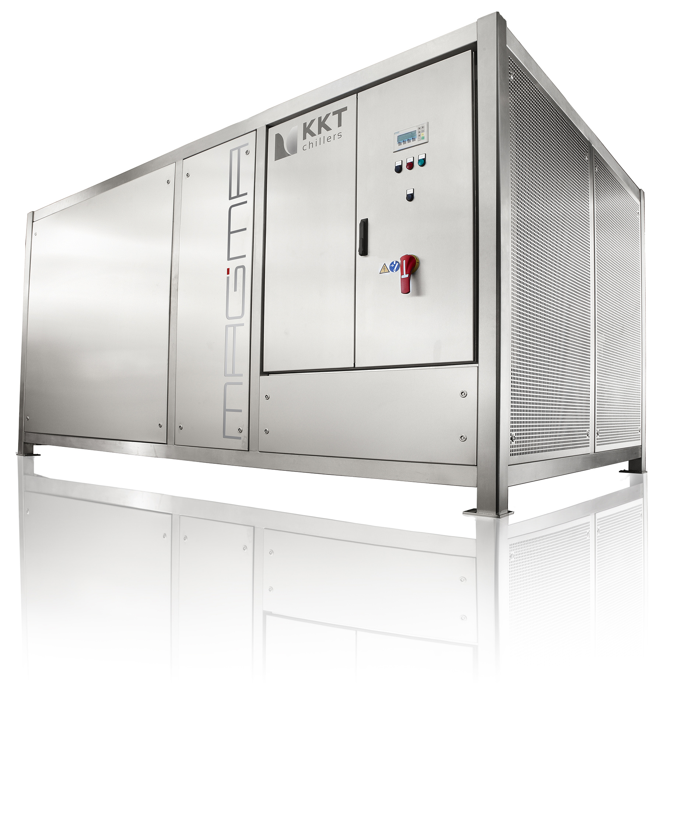

Image 2: High-performance heat pump MAGMA 500


Image 3: QR code product information THERMODYNAMIXX
Please send a sample copy to: nadine.stich@kkt-chillers.com

