
PRESS RELEASE
Efficient. Compact. Innovative.
KKT chillers presents the new Compact-Line.
KKT chillers introduces a new product line in the performance range of 30 – 200 kW in cooling capacity. With a range of twelve units, “cBoxX 30 – 200”, in four different housing sizes, the Compact-Line sets new standards in efficiency, compact design and innovation in chiller technology. All models’ sophisticated industrial design points to the great range of innovations incorporated into these powerhouses of the latest chiller generation.
They all have one thing in common: They offer maximum performance at a minimum amount of space.
A look inside any of these models is like a glimpse into a new world of fulfilling customer wishes. Each assembly group can be customized to fully meet the specific purpose of the respective customer application; depending on a customer’s requirements, this can be done at the plant or during operations via the user-friendly control surface:
All the crucial parameter – such as temperature, pressure, tank filling level as well as all status notifications – are displayed in plain text and, thanks to the controller board developed in-house, can be managed at any time right at the unit or via one of the available communication interfaces. KKT chillers offers a variety of linking options for all the important fieldbus and industrial Ethernet networks such as CANopen, DeviceNet, Modbus, Profibus, etc. Remote maintenance and updates via the Internet and the app or USB are also possible.
Unparalleled in operations and maintenance.
Operating costs are minimized in the medium and long term thanks to a 20% reduction in electric power consumption, achieved by the application of highly efficient scroll compressor technology, which is harmonized perfectly with the refrigerating agent R410A as well as variable-frequency EC ventilators.
Another efficiency benefit is entailed in the introduction of the electronic expansion valve with complete closure characteristics, which allows for an optimization of the partial load behavior via an infinitely variable control system.
Thanks to innovative heat exchange technologies, such as Microchannel and the asymmetrical plate heat exchanger, the refrigerant filling level can be reduced by up to 75%. This brings about great benefits as far as logistics and maintenance are concerned.
All of these innovations are placed within a minimum amount of space so that, depending on the individual model, the unit can be placed at about any spot in the machinery or equipment pool.
“Innovation is our Standard” – cool solutions “made in Germany.”
Each KKT chillers product development always focuses on what our customers desire. So in a way, it is customer wishes that determine the selection of components every time anew. The resulting product portfolio ranges from series-oriented standard units to customized special solutions. The product series Nano-Line and Compact-Line, which offer a cooling capacity of up to 200 kW, are complemented by thermal energy solutions: THERMODYNAMIXX. This offering includes everything from energy saving systems and heat regeneration to heating and cooling solutions for industrial and technical building applications as well as special solutions for high-temperature areas and water management systems with the corresponding services. For the OEM industry, KKT chillers develops specific, globally applied cooling solutions in cooperation with the customers.
KKT chillers has long become a full-fledged global player in the chiller market, thanks to the two sites in Germany and the US as well as the global service network – plus the priceless benefit of technological development and production “made in Germany.”
Kasendorf, May 2013

Published by:  ait-deutschland GmbH  Industriestraße 3  95359 Kasendorf  Germany  T +49 9228 9977 0  F +49 9228 9977 149  E info@kkt-chillers.com  W www.kkt-chillers.com | For media inquiries please contact:  Nadine Stich  Marketing and Communication Industriestraße 3  95359 Kasendorf  Germany  T +49 9228 9977 0  F +49 9228 9977 149  E nadine.stich@kkt-chillers.com

About the brand:
Since 2012, KKT chillers has applied the company’s experiences and core competences at the Kasendorf site where it now develops, as part of ait-deutschland GmbH, joint projects on the energy-efficient use of resources with the brands Alpha-InnoTec and Novelan. Last year, ait-deutschland GmbH’s team of 490 people generated a turnover of € 145 million, with KKT chillers accounting for € 17 million.

Press photos:
Image 1: Logo KKT chillers

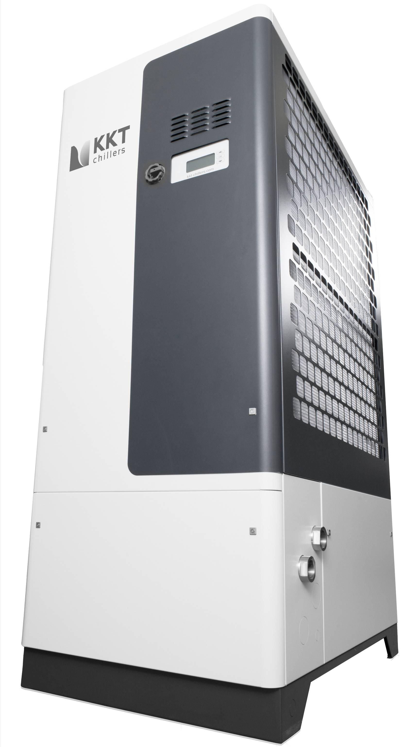

Image 2: cBoxX 60, Compact-Line (housing size 1)


Image 3: QR code product information + video

Please send a sample copy to: nadine.stich@kkt-chillers.com

