

PRESS RELEASE

KKT chillers provides the University of Bayreuth with two process chillers for various projects.

**The existing cooling water system at the University is not always consistent, but can now be kept at a solid temperature throughout the year by the chiller of the Vario-Line. This enables exact test conditions as many projects involve condensing at low temperatures.**

Vario-Line also helps with load changes by using an RPM-regulated compressor as well as an RPM-regulated fan. Thanks to a steadily regulating electronic expansion valve, the cooling capacity of the Vario-Line automatically adapts to the respective application’s currently available load profile. This means that the system generates only as much capacity as is needed at the moment.

Because of the chiller vBoxX 12, Florian Heberle, leader of the panel for energy systems and -technologies can remain level-headed and focus on ongoing and future project targets.

“Geothermie-Allianz Bayern: Teilprojekt “Effiziente und flexible Kraftwerke”, a 4-year-project requiring coolant with solid temperature is performed in cooperation with the TU Munich and funded by the Bavarian State Ministry for Education, Science and Art.

The project should examine power plants in respect to geothermal energy generation, focusing on possible cycle concepts and applied fluids, which allow high efficiency and flexible heat extraction. Measurements to increase efficiency should be realized through a testing device. In addition, a compact construction should be achieved, whereby sensible selection and arrangement plays an important role. On future power market scenarios, chances and risks for providing control energy with geothermal systems in cogenerations are scheduled to be rated and, in close cooperation with operators, the own requirements of existing geothermal devices should be reduced. Besides the centrifugal pump, the condensing concept has to be examined, which can be distinguished between indirect condensation through a cooling circle and direct condensation of the work medium through air condensers. Hybrid varieties allow extraordinarily efficient recooling.

About the panel for energy systems and –technologies

The panel for energy systems and –technologies is primarily concerned with circle processes and technologies for efficient power generation, heat generation and refrigeration as well as their intelligent relay to cogeneration. Other research focusses are concepts for the utilization of waste heat, heat transfer while evaporation and condensation as well as ecobalance and thermoeconomical analysis of energy conversion processes. The development and analysis of innovative systems is based on the following methods:

* Stationary and dynamic process simulations
* CFD-simulation of device components
* Experimental examinations (e. g. ORC-Testing-Device, test stands for heat transfer and thermal stability)

Kasendorf, July 2018

|  |  |
| --- | --- |
| Herausgeber:  ait-deutschland GmbH  Industriestraße 3 95359 Kasendorf  T +49 9228 9977 0 F +49 9228 9977 149 E info@kkt-chillers.com W www.kkt-chillers.com | Pressekontakt:  Nadine Stich Marketing and Communication Industriestraße 3 95359 Kasendorf  T +49 9228 9977 0 F +49 9228 9977 149 E nadine.stich@kkt-chillers.com |

Pressefotos:



Picture 1: Logo KKT chillers

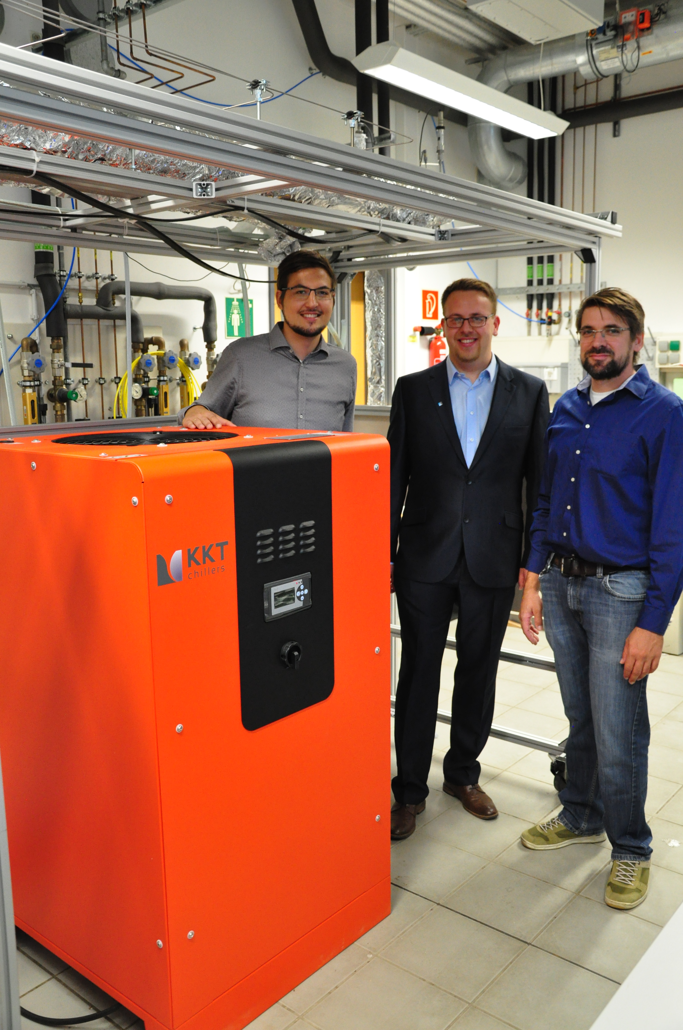

Picture 2: Handover of the vBoxX (chiller with 8 kW cooling capacity) by Mr. Tobias Engel (ait-deutschland, development cooling) to Mr. Matthias Welzl (left) and Mr. D.Eng. Florian Heberle (right) from the University of Bayreuth, panel for energy systems and –technologies.

Please send proof to: nadine.stich@kkt-chillers.com