KKT_Logo_RGB

SPECIALIST ARTICLE

*Main Headline:*

**Cooling solutions for laser applications**

*Subtitle:*

Why a customized chiller supports a laser’s optimal performance and reduces energy costs.

*Authors: Markus Zobler, Eike Mantwill, Dominik Pflieger*

*Introductory text:*

In cutting, welding and additive manufacturing, lasers are a universal tool. To make sure that a laser operates reliably, its components must be cooled as the generation of the laser light creates heat. If this heat is not discharged, both the laser and the workpiece will heat up. Heat can diminish the accuracy of the laser beam and even deform parts of the laser. To prevent temperature fluctuations and damages, laser manufacturers apply cooling units, called chillers. Based on the operating principle of chillers, this article explains why it is well worth it for laser manufacturers to consider suitable cooling of individual elements already in the development phase.

*Main text incl. Sub-Headlines*

CO2, disk, diode and fiber lasers: they all need reliable cooling for their resonators, optics and laser heads, even during load fluctuations, to provide consistently high results. A chiller should always maintain the exact temperatures, meaning the defined flow temperature in both the full and partial load range, with fluctuations preferably as little as +/- 1 Kelvin (K). Depending on the specific load profile, lower temperature fluctuations are feasible as well.

This article first explains the construction and operating principles of chillers, demonstrating that there are a multitude of variations when building a customized chiller.

If laser manufacturers include these issues in their concepts early on, they benefit when their lasers are operational. In reality, however, this approach is still uncommon, and cooling usually plays a minor role at this stage. Often, there is not enough time to plan a perfect cooling solution. As a result, companies waste some of a laser’s potential. After all, the better the chiller is adapted to the laser, the higher the temperature and control accuracy, and consequently the better the results.

**How does the refrigeration cycle work?**

The chiller’s refrigeration cycle works with an air- or water-cooled condenser. A key advantage of air cooling is that it allows the refrigeration cycle to run autonomously, without an additional cooling source. The chiller discharges the waste heat to the environment, that can be used for heating in winter. A water-cooled condenser, on the other hand, discharges the waste heat to the existing cooling water network, rendering the chiller independent of the ambient temperature.

How does a chiller cool? In the following, we first explain the vapor refrigeration compression process based on the example of the common air cooling. The chiller’s refrigeration cycle consists of the main components compressor, condenser, expansion valve and evaporator **(Illustration 1)**.The refrigerant circulates in this cycle, absorbing heat from the cold water in the condenser and discharging it to the intaken ambient air in the evaporator.

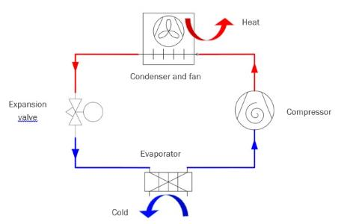

## **Illustration 1: Structure and operating principle of the chiller**

The **compressor** generates the pressure difference necessary for evaporation and condensation in the refrigerant cycle. Gaseous refrigerant coming from the evaporator is sucked in and compressed to the condensation pressure in the compressor. The **compressor** is a plate heat exchanger that transfers heat from the cold water to the refrigerant. To facilitate the heat transfer, the refrigerant in the compressor is colder than the cold water. In the heat absorption process, it changes its physical state from liquid to gaseous. The **condenser** is a micro-channel heat exchanger. It discharges heat from the refrigerant to the ambient air. To do so, the refrigerant in the condenser must be warmer than the intaken ambient air. In the heat discharge, it changes its physical state from gaseous to liquid. The **expansion valve** regulates the compressor admission of liquid refrigerant and at the same time curbs the pressure of the refrigerant before it enters the compressor. In doing so, the refrigerant cools down to the evaporation temperature. The **fan** sucks in the cooling air from the environment through the condenser and discharges the warmer air upward out of the chiller. A chiller does not only cool the laser system, it also offers integrated threshold monitoring that protects the laser system against too high or too low temperatures, depending on the refrigerant cycle.

**Variant: Water cooling**

If a cooling water network exists and the preference is to prevent warm exhaust air from the chiller, the refrigerant cycle can also work with a water-cooled condenser.

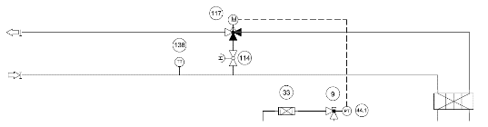

Illustration 2: Water cooling scheme (section of flow chart)

9 Rotalock valve

33 Filter dryer

44,1 Pressure sensor

114 Shut-off valve (manual)

117 3-way valve

138 Temperature sensor

In this system, the micro-channel heat exchanger is replaced by a plate heat exchanger, and the fan by a 3-way valve. The plate heat exchanger with copper-brazed stainless steel plates serves as a condenser. The 3-way valve is located in the cooling water discharge area and is controlled by an actuator in accordance with the condensation pressure. The closing of the additionally anticipated bypass valve can be switched from 3-way to 2-way control. The temperature of the cooling water is recorded by an additional temperature sensor and shown on the controller display.

**Requirements of perfect cooling: Water cycle**

How do laser manufacturers define perfect cooling? And how can chillers cool the water exactly as needed? The most important task of the chiller is to accurately control temperature and water pressure. The better and more flexible a chiller is in doing so, the better the laser operation. One of the chiller’s key competences is the precise and reproducible control of the refrigeration cycle, water pressure and flow temperature. The refrigeration cycle consists of a mostly standardized assembly while the water cycle can vary depending on the project. This is why we will take a closer look at the water cycle and its effect on hydraulics.

**Coolants and hydraulics**

The coolant is a key component of every chiller and should be controlled, treated, filtered, demineralized and completely replaced periodically. The three main coolants are water (drinking water), a water glycol mix and deionized water (DI water). The specifications of the consumer to be cooled determine which coolant is used.

|  |  |  |  |
| --- | --- | --- | --- |
| Properties | Water | Water glycol mix | DI water |
| Thermal conductivity | + | - | + |
| Anti-freeze and corrosion protection | - | + | - |
| Costs | 0 | + | ++ |

**Illustration 3: Coolant properties**

The simplest and most common coolant is water. It is often treated with chemicals to prevent lime buildup, algae and corrosion. For chillers, water is the standard coolant, and hydraulic components do not have to be modified to accommodate the use of water.

When a chiller is set up outdoors and may be exposed to freezing temperatures or when the cold water flow temperature is below 10 °C, a water glycol mix is commonly used. Depending on the consumer, ethylene or propylene glycols combined with additives are used to prevent corrosion. What does that mean for the chiller? For one, the material compatibility must be guaranteed, for instance through the application of zinc-free pipes. On top of that, it must be verified that the pump is fitted with a suitable gasket and sufficiently dimensioned motor. Due to its thermodynamic material properties, glycol may reduce the cooling capacity, a fact that must be accurately calculated and factored in with the design.

Deionized, demineralized water, or fully demineralized water, is the best option when specific requirements of purity apply or when the consumer may not come into contact with salts. The use of DI water as a coolant entails the following consequences for the chiller design: Depending on the demineralization level, no non-ferrous metal is used in the water cycle; this includes copper, brass and red brass. Instead, a stainless steel pump is used for hydraulics. The chiller conductivity can be measured with an integrated conductivity sensor and controlled via a mixed bed cartridge to ensure permanent conductivity in the long term.

**Volume flow and pressure: Choosing the right pump**

Volume flow and pressure of the coolant are generated by the pump integrated in the chiller, which is flexibly adapted to the design of the consumer during the project stage. Some laser manufacturers, for instance, apply narrow pipes, which require higher pressure than others. Popular options include an individual consumer pump, two redundant pumps, or one pump for the internal water cycle and another for the consumer side. The third option is recommended for consumer cycles that require a very low volume flow at high performance, in other words, for major temperature differences between flow and return. If the focus is on energy efficiency and variable hydraulics, it may be worth considering a speed-controlled pump, which generates different pressures and volume flows on demand. It is a particularly interesting option for several consumers with different volume flows.

**Flow temperature and temperature consistency**

A consistent flow temperature and temperature accuracy of the chiller guarantee that the laser operates perfectly. The chiller manufacturer sets the flow temperature depending on the specific facility; it can also be changed during operations. Various chiller systems offer a variable temperature profile: To prevent the buildup of condensation, the flow temperature can be controlled, for instance, depending on the ambient temperature and humidity. In practice, however, most systems operate with a fixed operating point. Common flow temperatures in laser cooling range from 15 °C to 25 °C. The refrigeration cycle is planned accordingly and kicks in and turns off again as needed. Almost as important as the flow temperature is the temperature accuracy required of a chiller.

Illustration 4 and the related table explain the operating principle. The example shows a standard scheme with four compressor stages or compressors at a target value of 20 °C and temperature consistency of 2 K. In the event that the temperature rises by 0.25 °C, the first compressor turns on and only turns off again after it has lowered the coolant temperature to 19.75 °C (see left arrow, Ill. 4).

|  |  |  |
| --- | --- | --- |
| Y cooling stage 1 OFF | -25 | % |
| Y cooling stage 1 ON | 25 | % |
| Y cooling stage 2 OFF | -50 | % |
| Y cooling stage 2 ON | 50 | % |
| Y cooling stage 3 OFF | -75 | % |
| Y cooling stage 3 ON | 75 | % |
| Y cooling stage 4 OFF | -100 | % |
| Y cooling stage 4 ON | 100 | % |

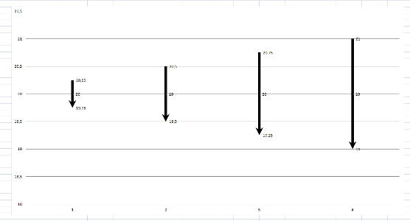

**Illustration 4: Standard cooling system with four compressor stages**

**Partial loads and volatile energy input**

The chiller’s compressor is designed in compliance with the required cooling capacity, including temperature consistency. But which laser runs constantly at 100 %? Full load is the ideal case, but partial loads and volatile energy input are standard in industrial operations. Both cases make it more difficult to meet the envisaged temperature consistency. Volatile energy input, for instance, is typical for diode lasers, for which the full load is reached immediately after turning on. To achieve greater temperature consistency, chiller manufacturers vary the tank size or the number of compressors, apply a hot gas bypass in the refrigeration cycle, or work with controlled compressors. A speed-controlled compressor offers several advantages: First off, only one compressor is needed and not four as in the example above. Moreover, the chiller works at a high energy efficiency level as it automatically adapts to the required load profile. We will come back to these aspects later in this article.

**Cooling solutions for two consumers, temperatures or coolants**

What is the recommended setup if a chiller must cool two components with different specifications, such as a laser head and optics? Optics need a higher water temperature to ensure that the laser’s mirrors don’t fog up. In case the optics contain copper components, a different coolant than for the laser may be required as well. To customize a chiller for the specifications of two components, two temperatures or two coolants, it makes sense to incorporate it already in the development of the laser.

If a chiller is supposed to cool two different consumers, it is designed with a view to volume stream, temperature and coolant pressure. If the task is, for instance, to cool the resonator and optics cycles, an additional water connection at the chiller may be planned in the design. For different pressure levels, the application of a second pump is feasible as well.

If cooling is required for two consumers with different flow temperatures, admixture systems have proven a favorable option. A typical example: The laser cycle has a flow temperature of 20 °C and the optics cycle of 30°C. This means for the warmer cycle that the coolant volume stream from the return is immediately added to the flow again via a 3-way valve without being cooled by the chiller first.

Another typical requirement is two different coolants, which may apply if the two cycles in the chiller differ, for instance if water and DI water are used, or if any admixture should be prevented in the case of copper and aluminum cycles. In such a setup, the two cycles are fitted with separate water tanks, pumps and other hydraulic components.

The many different requirements and design options show that to find the best solution, laser and chiller manufacturers should work together closely.

**How to achieve high control accuracy**

The control system is tasked with aligning the chiller’s refrigeration capacity to the required cooling performance as precisely as possible. But how can high control accuracy of the chiller – for instance for a typical target requirement of +/- 0.5 K with waste heat of 10 kW – be aligned with compact space requirements and energy efficiency? The following section provides different examples of cooling solutions.

As laser applications often show load fluctuations, thermal load is very rarely constant either. So, a large stainless steel tank can be used as a buffer for cooling.

The example in Illustration 5 demonstrates what would happen with a laser’s waste heat without that kind of water tank.

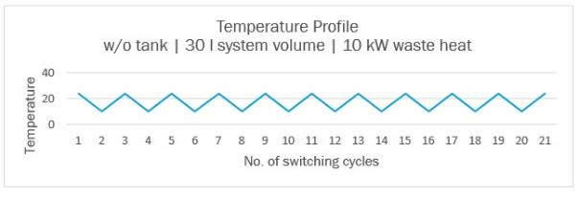





**Illustration 5**, top: Sample temperature profile with 14 K fluctuation.

Bottom: Simple water cycle with laser (left), plate heat exchanger (top right) and pump (bottom).

In this worst-case scenario, a water volume of 30 liters circulates in the chiller and the compressor turns on twelve times an hour. A temperature stability of 14 K (+/- 7 K) maximum is achieved, so the temperature fluctuates between 10 °C and 24 °C. Today, no laser manufacturer would accept such temperature fluctuations.

The next example shows a water cycle with a 100-liter tank and a water flow volume of 130 liters total. The typical number of switching cycles for a refrigerant compressor once again is twelve per hour. Illustration 6 demonstrates that, thanks to the water tank, the fictitious water cycle now has a temperature profile of +/- 2 K and, consequently, a temperature fluctuation of between 10 °C and 14 °C, again a value few manufacturers would accept for their laser applications.

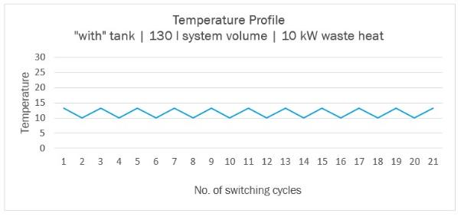



**Illustration 6**, top: Sample temperature profile with 4 K fluctuation.

Bottom: Water cycle with laser (left), plate heat exchanger (top right), tank (right) and pump (bottom).

As the target value for the sample waste heat of 10 kW, a control accuracy of +/- 0.5 K is initially anticipated. To achieve this, it seems evident that the tank must be larger. The third example uses a 400-liter water tank and thus a water flow volume of 430 liters. All other elements and the number of switching cycles remain exactly the same as in the previous examples.

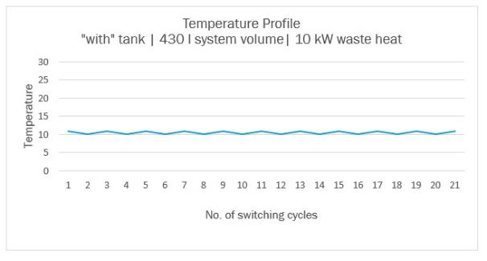

**Illustration 7**: Sample temperature profile with 0.5 K fluctuation, laser 100 % when compressor turned off, laser 0 % when compressor turned on; theoretical consideration without further thermodynamic impacts.

Consequently, in this scenario, a tank volume of up to half a ton of water would be required to achieve a temperature stability of +/- 0.5 K. The problem with this theoretical solution is obvious: Chillers have a space requirement of c. 80 x 80 cm, so where should the operator place a tank of this size? Setup space and weight, installation and operating costs, as well as the response time of the chiller (due to the long cooling-down time) are simply inacceptable. In practice, smaller tanks are commonly used. Instead, the chiller is equipped with an additional hot gas bypass as a capacity controller. In this setup, the hot gas made available to the refrigeration cycle is fed into the heat exchanger where it swiftly reduces the currently available cooling capacity. In other words, energy not required in the form of cooling capacity is obliterated. Depending on design and external conditions, the water flow temperature can be kept within a fairly limited range; values of +/-2 K to +/-1 K are often feasible.

To achieve rather balanced cooling operations, however, the facility’s efficiency is significantly reduced.

Nevertheless, this control system has become common practice in the past decades. The customer benefit is clear: The system ensures both stable temperatures and smooth laser operation. Energy consumption, on the other hand, plays only a minor role in the considerations.

In view of rising energy prices (Illustration 9*)* and the desire to increase sustainability in the use of resources, more and more companies are rethinking this approach. Based on the tried and tested cooling method with a tank, the question now is how the hot gas bypass could be circumvented or changed. The answer is illustrated in the next example and is not fictitious but current state of the art. To achieve the requested temperature stability with a deviation of 0.5 K maximum, a 100-liter tank with a speed-controlled compressor is used.

Depending on the load profile and operating conditions of between 10 % and 100 %, the compressor allows for the continuous adjustment of the cooling capacity to the current flow temperature or other requirements.

**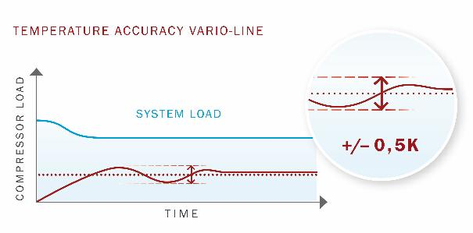**

**Illustration 8: Speed-controlled compressor for continuous temperature control.**

The cooling concept consisting of a speed-controlled compressor and tank offers laser manufacturers major benefits: The chiller can be adapted to the load profile of the process at any time and always deliver the required flow temperature. At the same time, the system lowers operating costs\* and thus the total costs of ownership (TCO).

The compressor’s switching cycles can be reduced to a minimum.

Contrary to the above-mentioned 430-liter tank, no long cooling-down times are required. When the compressor is turned off, the facility is available again within only a few seconds.

\*The operating costs of a chiller include its cleaning (especially for air-cooled facilities), filter exchange (DI filter/water filter/control cabinet filter), energy and maintenance. Even if the chiller only accounts for a fraction of the facility’s energy costs, the operating costs should not be underestimated.

**Electricity Prices for the Industrial Sector (w/o electricity tax)**

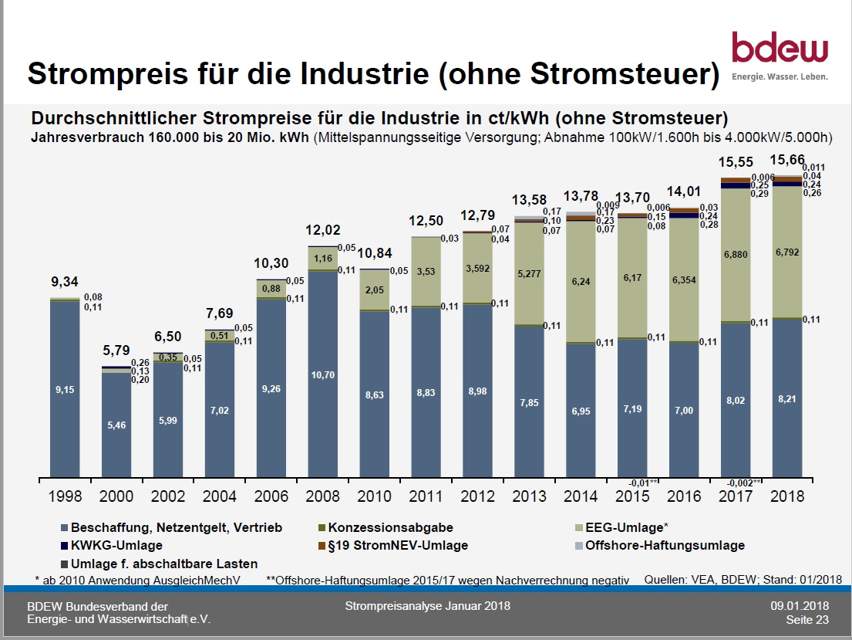

**Illustration 9**

**Source: Federal Association of the German Energy and Water Industries (BDEW)**

<https://www.bdew.de/media/documents/180109_BDEW_Strompreisanalyse_Januar_2018.pdf>

**Speed-controlled components align automatically**

Full-load, standby and partial load laser operations come with different cooling requirements. In these processes, the cooling water flow volume fluctuates between 40 % and 100 %. The speed-controlled pump described in the section on “Volume flow and pressure” can demonstrate its benefits here. Based on communication between the laser and chiller, the pump can significantly reduce the chiller’s energy consumption. Just like the speed-controlled compressor, the pump also serves the purpose of operating the cooling process with maximum accuracy. One example for its effect: The laser operates at 100 % utilization, as does the chiller, and the water flow volume is 200 liters. Now the laser turns off. Without communication, the chiller continues to run at full capacity as the chiller only registers that the heat input has stopped when the water temperature decreases. For a water-cooled facility, the energy efficiency ratio (EER) at this operating point is 3.5.

If the chiller went down to 40 % of its maximum output as soon as the laser is turned off, the EER would go up to 5 or higher. Further optimized, the chiller could even turn off up to a minute before the laser, depending on cycle time. Consequently, the energy expenditure of the chiller would be lower in each tool or sheet steel change, making a positive contribution to the operating costs throughout the lifecycle.

**Efficiency comparison of variable vs. hot gas bypass control**

Does the energy demand change if you use a chiller with a speed-controlled instead of a fixed compressor? Not as first glance, as the kilowatt demand does not depend on the type of drive control but on the water temperature and flow volume. So, the energy demand remains unchanged at 10 kW. However, the identical compressor performance only applies at the maximum operational performance of the laser, so 100 % = 100 %. In reality, the facility’s energy demand does not stand at 0 % or 100 %. Rather, it varies constantly, due to the laser’s different operating mode.

In the case of a partial load, the advantages of speed control become apparent: The compressor reduces its rotation speed due to the lower performance requirements of the cooling water and thus changes its operating parameters fundamentally because a compressor conveys and condenses the intaken refrigerant. Its operation depends significantly on the difference in pressure. From a thermodynamics perspective, the evaporation temperature is 3-5 K lower than the flow temperature in the cold water cycle, depending on the frame size of the compressor (plate heat exchanger). As a rule, the condensation is 10 K higher than the ambient temperature. If it were different, a heat transfer would not be possible. This general design will be considered as a given in the following. Consequently, the pressure ratio at the compressor in operations is defined. If you now reduce the rotation speed of the compressor, the refrigerant mass flux in the compressor is reduced and the evaporation temperature inevitably increases. At this operating point, the plate heat exchanger has a high space reserve.

The low mass flux leads to the same effect on the water- or air-cooled condenser. At a constant fan speed and ambient temperature, the condensation temperature decreases.

The pressure ratio of the compressor lowers and reduces its work load. It thus reaches a more efficient operating point, which manifests itself in the compressor using less power.

An example and the associated illustrations, Ill. 10 to 13, visualize the principle. We compare the performance of a chiller A with a 100-liter water tank and hot gas bypass and that of a chiller B with a 100-liter water tank and variable control (speed control). In both cases, the cooling capacity is 10 kW, the chillers are installed in a hall with a room temperature of 25° C. The laser’s performance requirement in the following example is constant at 3.3 kW.

**Illustration 10 and 11: Variant with 100-liter tank and hot gas bypass**

**Illustration 12 and 13: Variant with 100- liter tank and variable control (speed control)**

**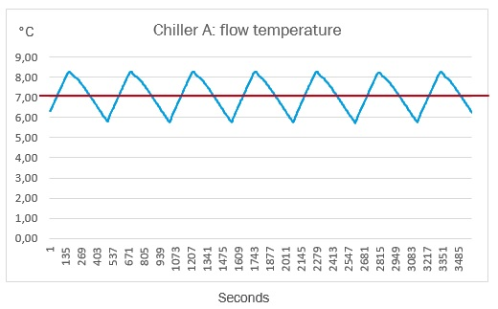**

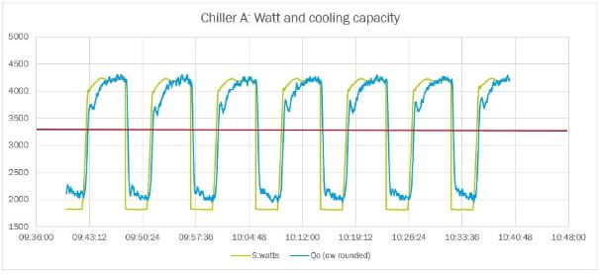

Chiller A, water-cooled, with 100-liter water tank and hot gas bypass

“Saw tooth” with 100-liter tank

Cooling capacity: 3.3 kW

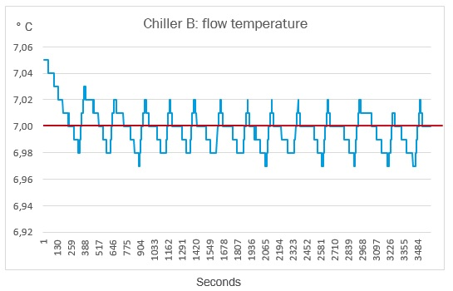

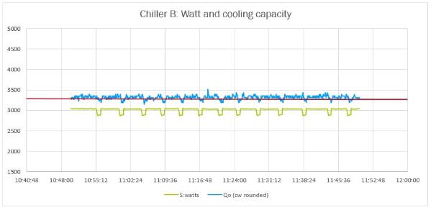

Rotation speed of compressor: 50/58 rps/seconds

Cooling capacity: 3.3 kW

With a hot gas bypass control, the chiller responds with a saw tooth temperature profile, in other words, with enormous fluctuations in flow temperature and cooling capacity. The speed-control chiller, on the other hand, adapts to the lowered cooling demand. So in the example, a reduction of at least 8 % compared to current compressor technology is achieved for the power consumption per hour.

**Outlook: The future of laser cooling**

The variable cooling concept described above can be developed further. So far, the requirement of the cooling performance must be detected indirectly via the temperature increase of the refrigerant. Naturally, this entails a delayed response of the chiller due to the system’s cycle time. The chiller only recognizes the load change when the process water reaches the temperature sensor. An even more exact and efficient control would be feasible if the laser and chiller communicated directly, and the chiller could cool anticipatorily based on the current laser performance instead of responding with a delay. In a time in which networked manufacturing is becoming standard and an increasing number of people are using smart home technologies, this thought is much more than a mere vision.

This means the target should be a continuous exchange of information between the laser and chiller, which would allow the chiller to “know” which cooling load would be required and how quickly it would have to be provided. The chiller could increase or decrease the cooling capacity anticipatorily and turn off the facility when the laser goes to stand-by mode. Consequently, the chiller could deliver best possible cooling quality at all times; at the same time, the size of the respective tank could be significantly reduced.

Benefits of this scenario would reach from energy savings, reduced space requirements and lower commissioning and installation costs to weight reduction and, consequently, lower storage and transport costs.

*Summary:*

Especially in a partial load scenario, a speed-controlled compressor offers economic benefits and helps preserve resources. A variable chiller that flexibly adapts to the laser’s energy demand (keyword “speed-controlled”) decreases energy consumption and thus total cost of ownership (TCO). To make the most of the advantages of a modularly designed chiller, it is worthwhile for laser manufacturers to understand how a chiller works and to plan for suitable cooling already during the development phase of the laser. This guarantees the optimum performance of the laser, and saves on energy costs and space requirements. Continuous communication between the chiller and laser will in future entail even greater savings. The future belongs to cool and smart solutions.

*Company Box:*

KKT chillers was founded in 1978 as KKT Kraus; since 2013, it is a brand of ait-deutschland GmbH. For more than 30 years, KKT chillers has offered its customers appealing and highly specialized solutions in refrigeration technology. As a specialist for cooling laser components, KKT chillers cooperates with leading manufacturers of CO2, disk, diode and fiber lasers to develop customized laser cooling solutions. The range comprises cooling technologies for thermal processes such as laser cutting and welding as well as additive manufacturing, such as 3D printing.

4.353 Words

About the authors (plus photos):



Markus Zobler: Started 20 years ago as Technical Customer Support and Product Manager at KKT Kraus Kälte- und Klimatechnik GmbH. Since 2008 Manager Development at KKT chillers (formerly KKT Kraus).



Dipl. Ing. Eike Mantwill: Mechanical engineer with specialization energy management in the technical university of Dresden (Germany) with 16 years experience in the cooling business. Has been working at KKT chillers for 5 years in responsibility as a Project Manager for the industrial sector.

  
Dominik Pflieger: Graduation from the technician school Würzburg (Germany) with 13 years experience in the development of chiller solutions. Has been working at KKT chillers for 4 years in responsibility as Development Engineer and 2 years as Product Manager.